Generic Elective (Semester –I)
Computer Science
By: Lucky Lao
Course: B.Sc. (Hons.) Mathematics
College ID: 23BMAT019
Q1. WAP to find the roots of a quadratic equation.
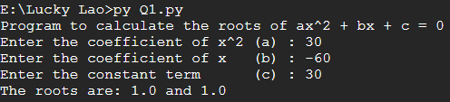

Q2. (This program may be done using functions)
WAP to accept a number ‘n’ and
- Check if ’n’ is prime

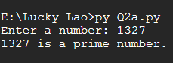

- Generate all prime numbers till ‘n’

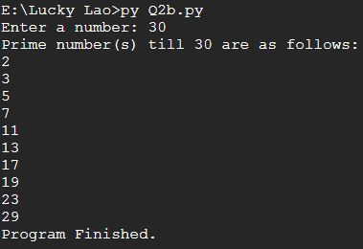

- Generate first ‘n’ prime numbers

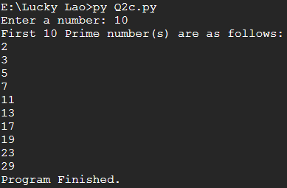

Q3. WAP to create a pyramid of the character ‘*’ and a reverse pyramid

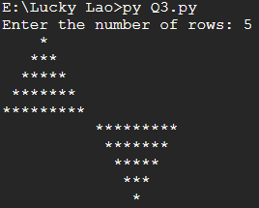

Q4. WAP that accepts a character and performs the following:
- print whether the character is a letter or numeric digit or a special character

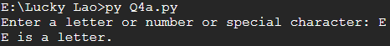

- if the character is a letter, print whether the letter is uppercase or lowercase

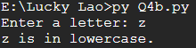

- if the character is a numeric digit, prints its name in text (e.g., if input is 9, output is NINE)

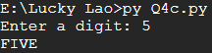

Q5WAP to perform the following operations on a string
- Find the frequency of a character in a string.

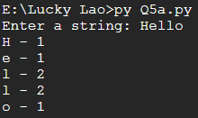

- Replace a character by another character in a string.

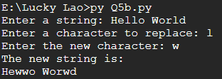

- Remove the first occurrence of a character from a string.

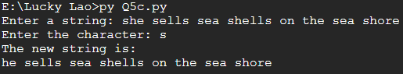

- Remove all occurrences of a character from a string.

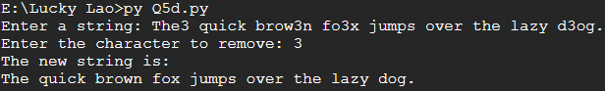

Q6. WAP to swap the first n characters of two strings.
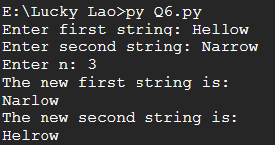

Q7. Write a function that accepts two strings and returns the indices of all the occurrences of the second string in the first string as a list. If the second string is not present in the first string then it should return -1.
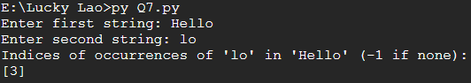

Q8. WAP to create a list of the cubes of only the even integers appearing in the input list (may have elements of other types also) using the following:
- ‘for’ loop

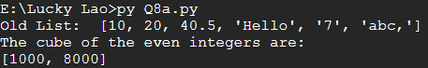

- list comprehension

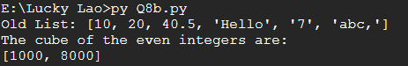

Q9. WAP to read a file and
- Print the total number of characters, words and lines in the file.

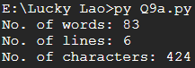

- Calculate the frequency of each character in the file. Use a variable of dictionary type to maintain the count.

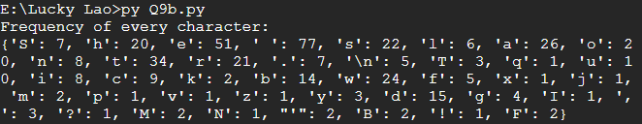

- Print the words in reverse order.

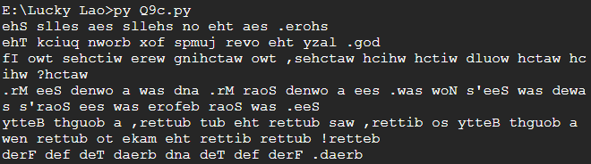

- Copy even lines of the file to a file named ‘File1’ and odd lines to another file named ‘File2’.

(No Output in Terminal) Result: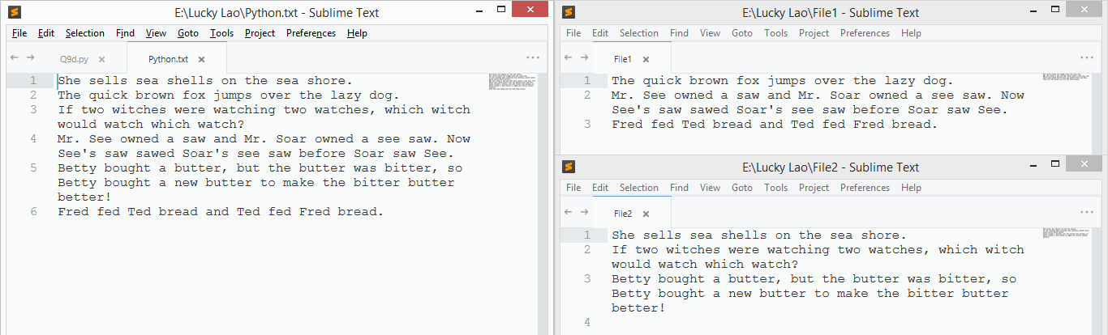

Q10. Write a function that prints a dictionary where the keys are numbers between 1 and 5 and the values are cubes of the keys.
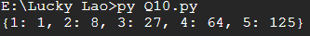
Q11. Consider a tuple t1=(1, 2, 5, 7, 9, 2, 4, 6, 8, 10). WAP to perform following operations:
- Print half the values of the tuple in one line and the other half in the next line.

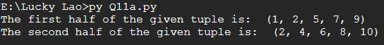

- Print another tuple whose values are even numbers in the given tuple.

- Concatenate a tuple t2=(11,13,15) with t1.

- Return maximum and minimum value from this tuple

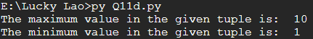

Q12. WAP to accept a name from a user. Raise and handle appropriate exception(s) if the text entered by the user contains digits and/or special characters.
